CASE STUDY-SQL

Emad Asher & Abhishek Dandona

**Requirements taken for a Car Insurance company.**

Listed below are the data requirements for customer,vehicle,policy,sales,employee,team,policy type, inspection,claim,addons,employee class and garage.

* The company database has data of customers, vehicles, policies, inspections, claims, garages.
* Customer details are customer ID, first name, last name, age, gender, location.
* Vehicle details are Vehicle Id, make, model, manufacturing year, price
* Policy details are policy number, premium,start date, end date
* Addons details are add on id, name rate
* Policy types details are type and rate
* Sales details are sale id, sale date
* Employee details are employee id, first name, last name, commission, salary
* Team details are team id, name, manager id
* Employee class details are employee class, lower limit , upper limit, rate
* Inspection details are inspection id, start date, end date
* Claim details are claim id, status, approval date
* Garage details are garage id, name, location
* A customer can have several vehicles, but a vehicle can have only one policy.
* Employees receive commission at a fixed rate on their sales. The rate is different for each employee class, where the employee class is determined on basis of number of sales. Better performing employees get more commission.
* Each employee is a team member and each team has a manager.
* A policy has three types, having different coverage. One addon can be added to a policy.
* When a customer applies for claim, the car is inspected first and then claim is either approved or rejected, if approved the car is taken to a garage for repairs.

**Schema Diagram**

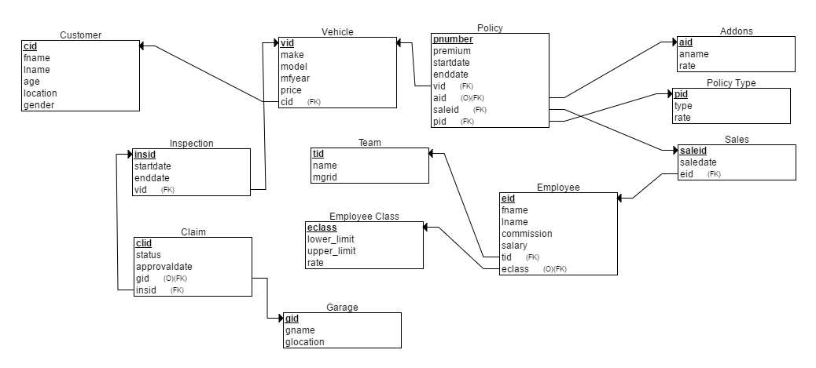

**E-R Diagram**

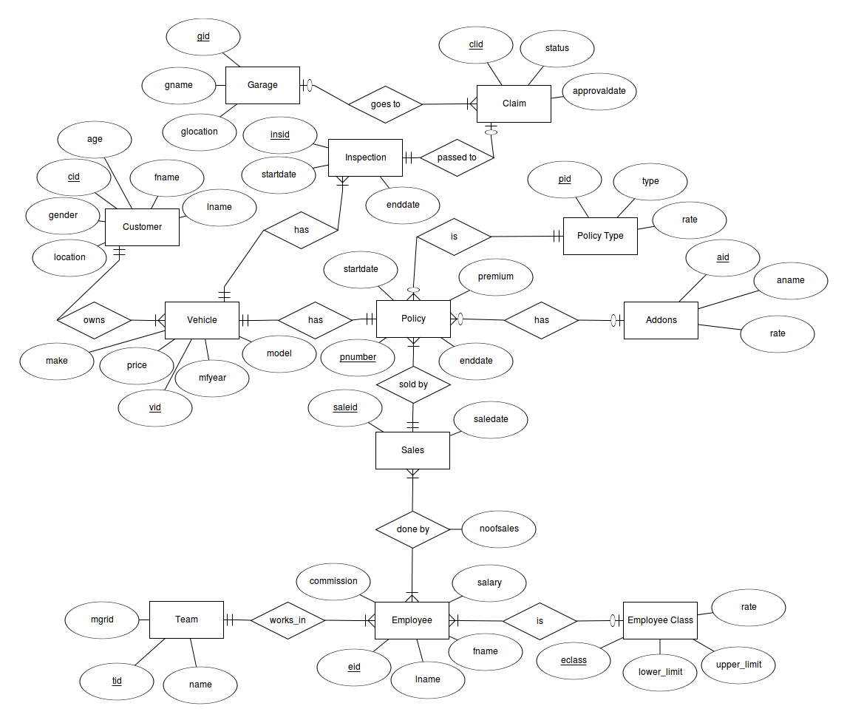

**Business Relation Table**

|  |  |  |  |
| --- | --- | --- | --- |
| Query | Related Stakeholder / Revenue / Cost | Business Benefit | Group Member |
| Display the frequently occurring age of customers where claims have been approved. | Claims | Will provide data about risk related to age differences among customers. Design different premiums for that particular age group. | Abhishek Dandona  Emad Asher |
| During a particular period of time, display how many claims were approved / rejected . | Claims | To find average approval rate and also check for any abnormal approval rates . Review inspection policies and alter criteria for claim approval. | Abhishek Dandona  Emad Asher |
| Display which type of policy is in demand the most. | Policy Type | To find which is the most common policy and offer addons / rate changes to that policy. | Abhishek Dandona  Emad Asher |
| Which policies are due for renewal | Policy | To check which policies are about to expire and provide reminders to customers to renew it. Design special offers for that particular time period. | Abhishek Dandona  Emad Asher |
| How does age of the vehicle affect the claim requests. | Claims | To check whether older vehicles are prone to claim approval/ rejection. Change policy types for vehicles older than 4 years of manufacturing year. | Abhishek Dandona  Emad Asher |
| Measure the performance of employees and commission. | Employee and Sales | To see which class of employee is performing better, receive highest commission and optimize team performance. | Abhishek Dandona  Emad Asher |
| To find how many inspections performed in a day | Inspection | To find average time taken to perform inspection on a vehicle. Calculate trends in time & accidents. | Abhishek Dandona  Emad Asher |

**Queries**

1. Select c.age “Age”, count (cl.clid) “Number of claims” from customer c , vehicle v , inspection i , claim cl where c.cid = v.cid and v.vid = i.vid and i.insid = cl.insid and cl.status = “approved” group by c.age ;
2. Select count(cl.clid) a / count(cl.status) b from claim cl where a = (select count(*) from claim cl where cl.status=”approved”) and b = (select count(*) from claim cl) group by year(cl.approvaldate) ;
3. Select count(pt.type) “Number of Policies”,pt.type “Policy Type” from policytype group by pt.type ;
4. Select p.pnumber “Policy Number”, p.startdate “Start Date”, p.enddate “End Date” from policy p where p.enddate between date_sub(p.enddate , interval 1 month) and p.enddate ;
5. Select count(cl.clid) “Total claims” , v.mfyear “Manufacturing Year” from claim cl , vehicle v , inspection i where i.vid = v.vid and i.insid = cl.insid group by v.mfyear having cl.status=”approved” ;
6. Select e.eid “Employee ID”, e.fname “First Name”, e.lname “Last Name”, count(s.saleid) “Number of Sales”, e.commission “Commission” , ec.eclass “Employee Class” from employee e , sales s , employeeclass ec where ec.eclass = e.eclass and s.eid = e.eid ;
7. Select count(i.insid) / datediff(max(i.enddate) , min(i.startdate)) “Average number of inspections per day” , count(i.insid) “Total number of inspections” from inspection i ;